PROJECT REPORT
Project Title: Student Placement Tracker Using DynamoDB Local
Group Members:
- Anusha Madari
- Sumanjali Peketi
- Pavani Seliveru
Database in Use: Amazon DynamoDB Local (NoSQL Database)
Detailed Project Description:
Student Placement Tracker is the web application we developed to keep student placement details in one place. We can add student profiles, record job applications, schedule interviews, save job offers, and manage tasks. The dashboard gives us a quick view of the information entered in the system.
For the frontend, we used React, JavaScript, CSS, and Vite. We used React Router to move between the Dashboard, Students, Applications, Interviews, Offers, and Tasks pages. We also created reusable components for forms, buttons, and other common page elements.
For the backend, we used Node.js and Express.js to create REST APIs. When we add or change information on the website, the frontend sends a request to the backend. The backend checks the details and uses DynamoDB Local to save or get the records.
Project objectives:
• Centralize student and placement-related records.
• Provide a clear user interface for viewing and maintaining records.
• Demonstrate CRUD-style operations through a REST API.
• Demonstrate integration between a frontend, backend, and NoSQL database.
• Keep the code modular through separate pages and reusable components.
User Interface Details and Screenshots:
Figure 1. Dashboard :
On the dashboard, we can see a summary of our applications, interviews, and offers.
- Total Applications: 3 job applications recorded.
- In Progress: 2 applications are currently being processed.
- Upcoming Interviews: 3 interviews are scheduled.
- Offers Received: 1 job offer has been received.
- Recent Applications: Displays company names, positions, and application status.
- Application Stages: Shows the progress of applications through recruitment stages.
- Navigation Menu: Provides access to Students, Applications, Interviews, Offers, and Tasks.
Purpose: We use this page to check the overall progress without opening every section separately.
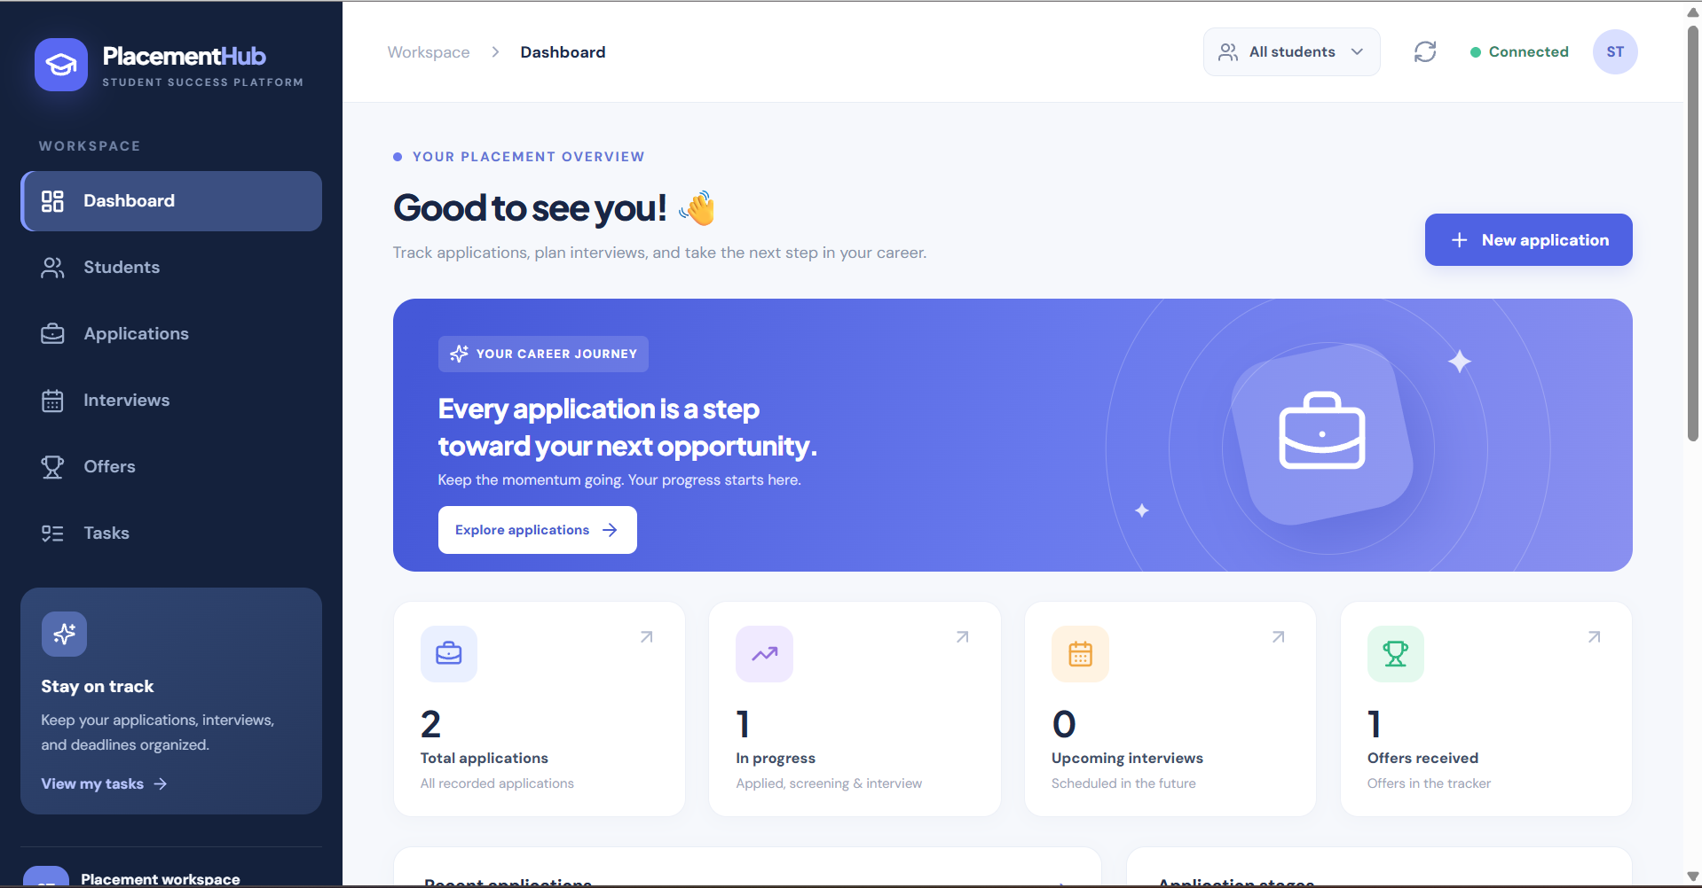
Figure 2. Students:
We use the Students page to add student profiles and view or change their details.
- Total Students: Displays 3 registered students.
- Student Details: Shows names, email addresses, majors, graduation years, and student IDs.
- Add Student: Allows users to register new students.
- Search: Helps find specific student records.
- Edit and Delete: Allows users to update or remove student information.
- Database Integration: Student records are retrieved from DynamoDB Local through the Express backend.
Purpose: This page keeps the student details together so we can link them to applications.
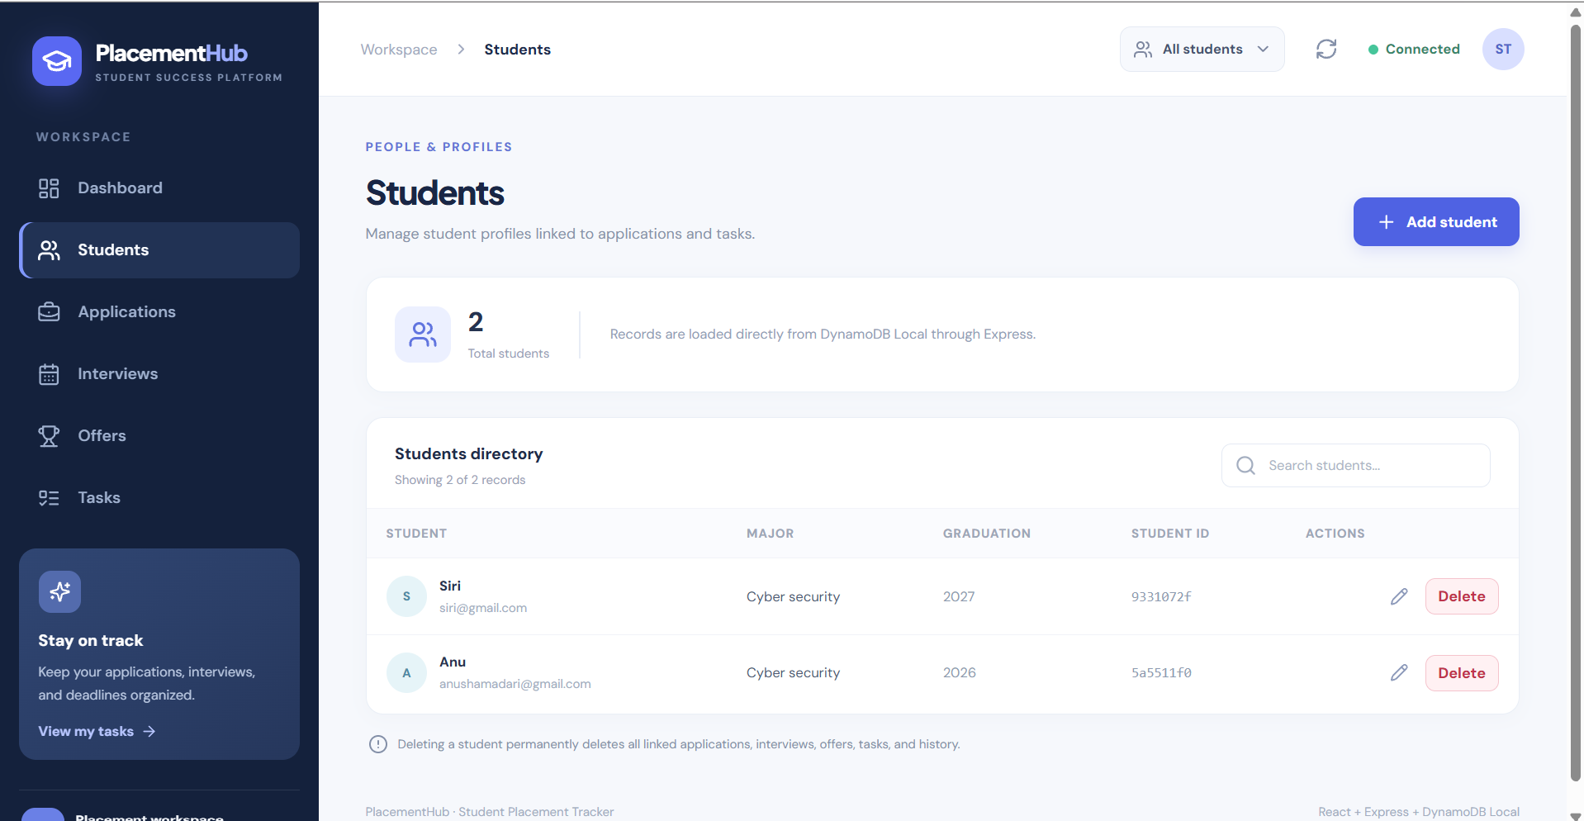
Figure 3. Applications :
We use the Applications page to add job applications and follow their status.
- Total Applications: Displays 3 recorded applications.
- Application Details: Shows company names, job positions, students, locations, and application dates.
- Application Status: Tracks recruitment stages such as Interview and Offer.
- Add Application: Allows users to create new job applications.
- Search and Filter: Helps find applications based on keywords or status.
- Edit and Delete: Allows users to update or remove application records.
Purpose: This page helps us see which companies students applied to and what stage each application is in.
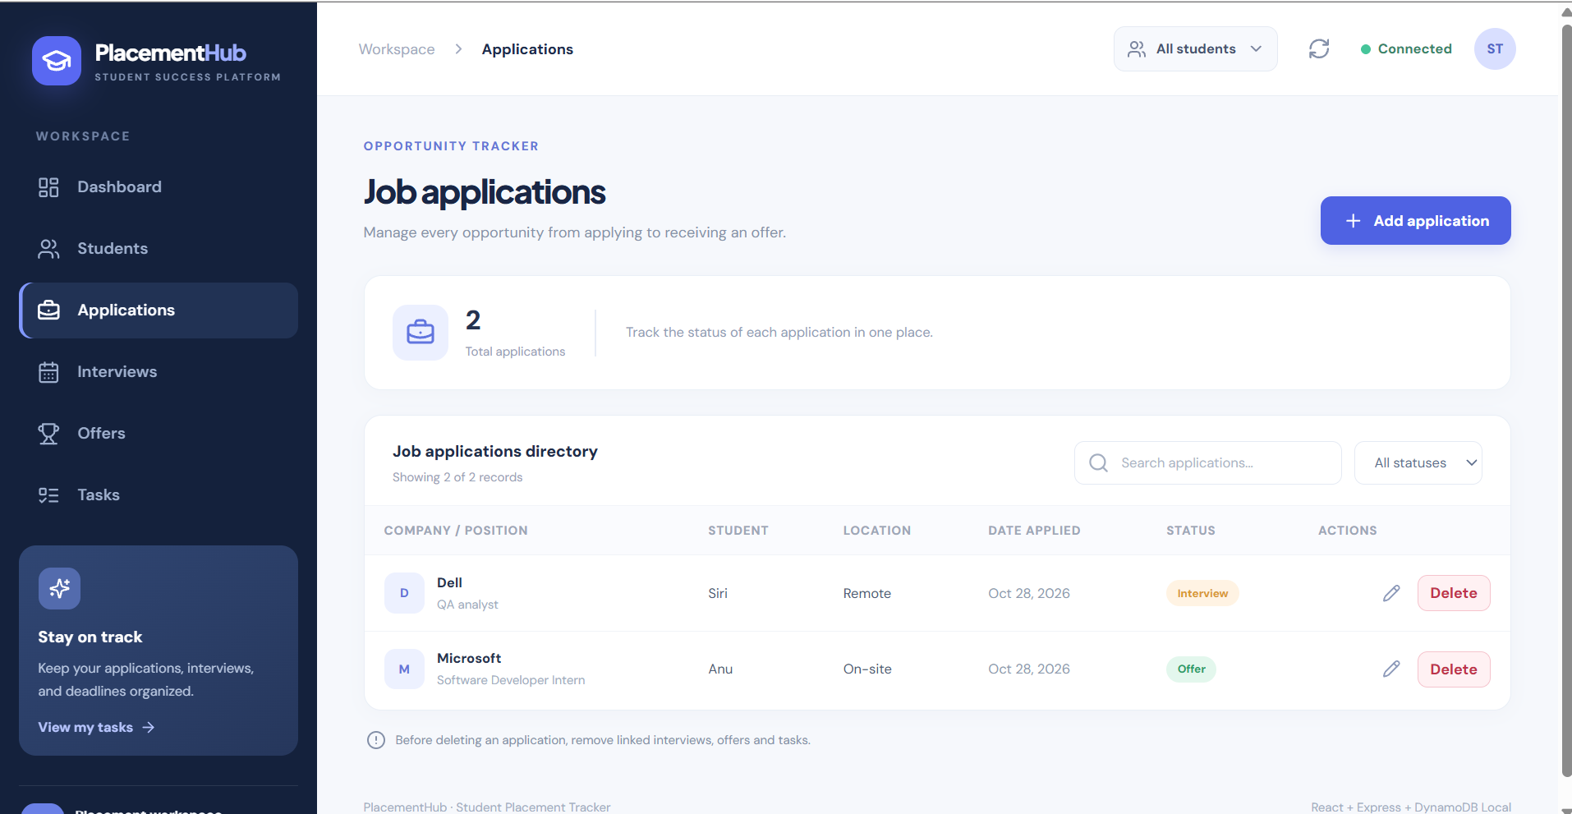
Figure 4. Interviews :
On the Interviews page, we can add interview schedules and update interview details.
- Total Interviews: Displays 3 scheduled interviews.
- Interview Details: Shows company names, job positions, interview dates, and interview types.
- Interview Status: Displays the current status of each interview.
- Add Interview: Allows users to schedule new interviews.
- Search and Filter: Helps find interviews based on keywords or status.
- Edit and Delete: Allows users to update or remove interview records.
- Database Integration: Interview details are retrieved from DynamoDB Local through Express.
Purpose: We use this page to keep interview dates and statuses in one place.
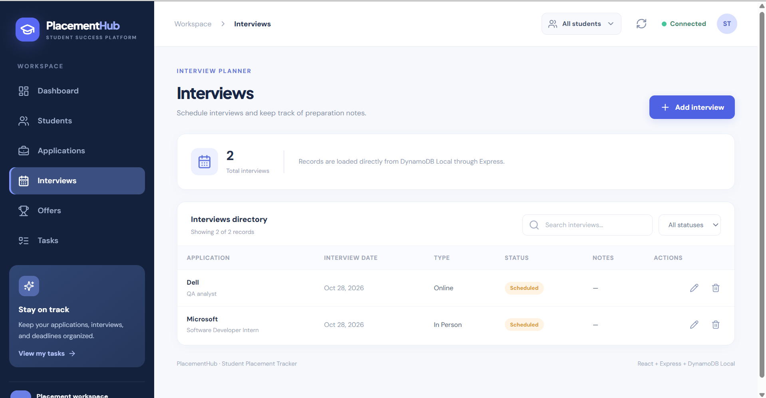
Figure 5. Offers :
The Offers page shows the offers recorded for job applications.
- Total Offers: Displays the number of recorded job offers.
- Offer Details: Displays information about each offer and its associated application.
- Offer Status: Helps track the progress of recorded offers.
- Add Offer: Allows users to create a job offer record.
- Search and Filter: Helps users find and review offer records.
- Edit and Delete: Allows users to update or remove offer records.
- Database Integration: Offer records are stored in DynamoDB Local and accessed through the Express backend.
Purpose: This page helps us keep track of offers and their results.
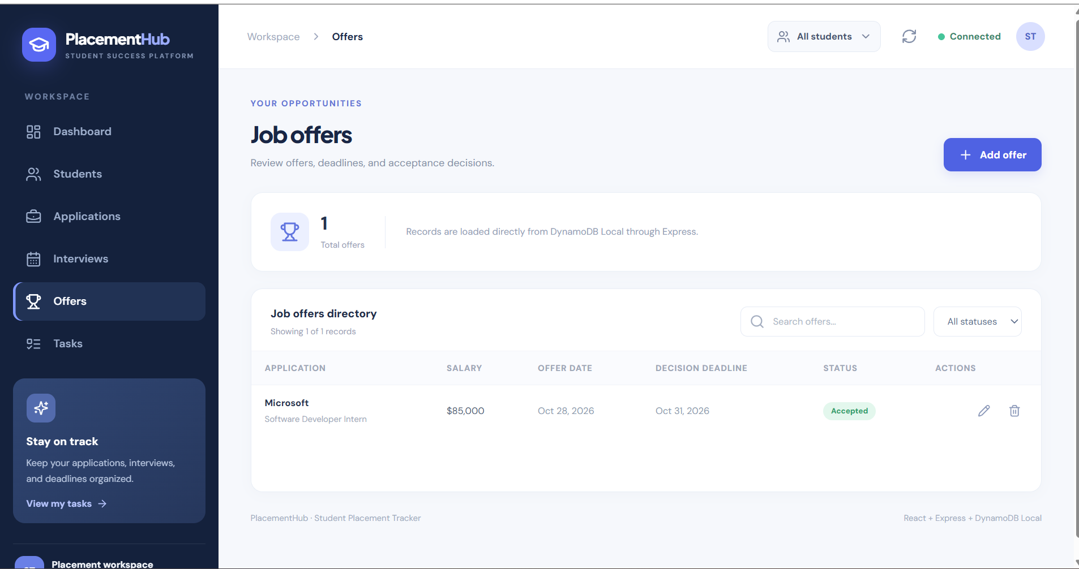
Figure 6. Tasks :
We use the Tasks page to record placement-related work and keep track of due dates.
- Total Tasks: Displays 1 recorded task.
- Task Details: Shows task name, associated company, due date, priority, and status.
- Task Priority: Indicates the importance of tasks (High).
- Task Status: Displays whether tasks are pending or completed.
- Add Task: Allows users to create new tasks.
- Search and Filter: Helps find tasks based on keywords or status.
- Edit and Delete: Allows users to update or remove tasks.
Purpose: This page helps us remember important follow-up work during the application process.
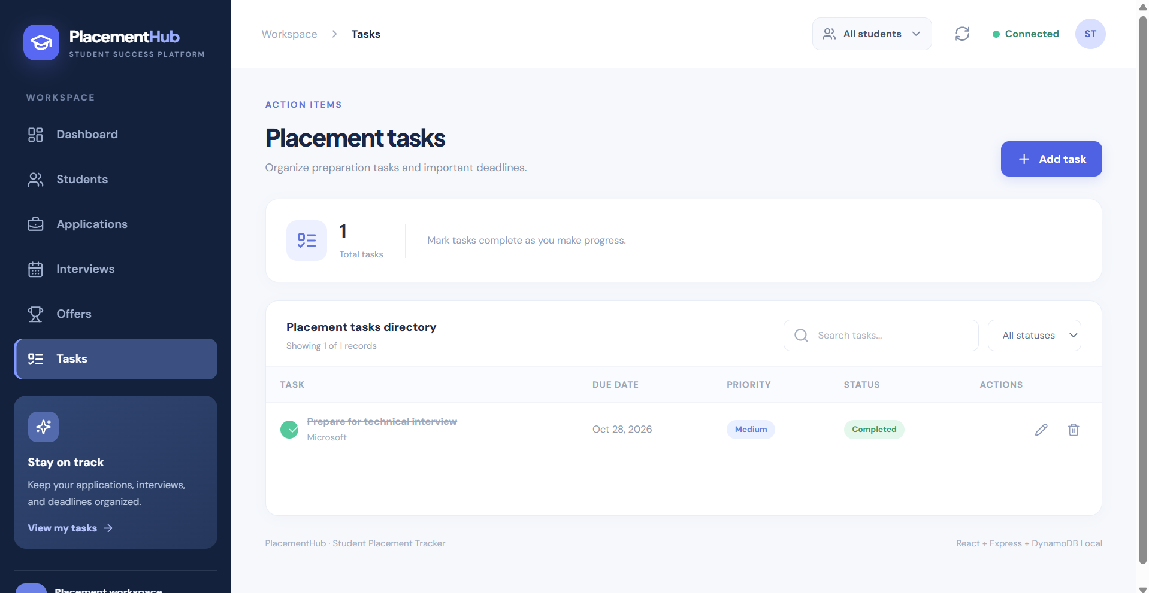

Database Usage
We used Amazon DynamoDB Local as the database for our project. It runs on our computer through Docker, so we could develop and test the application without using a cloud database. The Node.js backend connects to it using the AWS SDK for JavaScript v3.
Tables and primary keys
Table | Primary key | Data stored
Students | studentId | Student profiles
JobApplications | applicationId | Applications, companies, job titles, dates and statuses
Interviews | interviewId | Interview records linked to applications
Offers | offerId | Offer records linked to applications
Tasks | taskId | Placement tasks linked to students or applications
ApplicationActivity | activityId | Application status change history
We created six tables, and each record has its own ID. For example, every job application stores a studentId so we know which student applied. Interviews, offers, and application activity records store an applicationId to connect them to the correct application. DynamoDB does not use foreign keys like a relational database, so we check these links in our backend code.
Secondary indexes and access patterns
We added indexes so the backend can find related records without checking every item. JobApplications uses studentId-index; Interviews, Offers, and ApplicationActivity use applicationId-index; and Tasks uses both studentId-index and applicationId-index. We use GetCommand to get one record, ScanCommand for lists, and QueryCommand when searching with an index.
Connection and storage
We ran DynamoDB Local through Docker and connected to it at localhost:8002. We also used a Docker volume to keep the data when the container is stopped and started again. The backend connection files use port 8002.
Database testing evidence
We used a few database scripts to check whether the tables were created and whether records could be saved and read. The screenshots below show those tests.
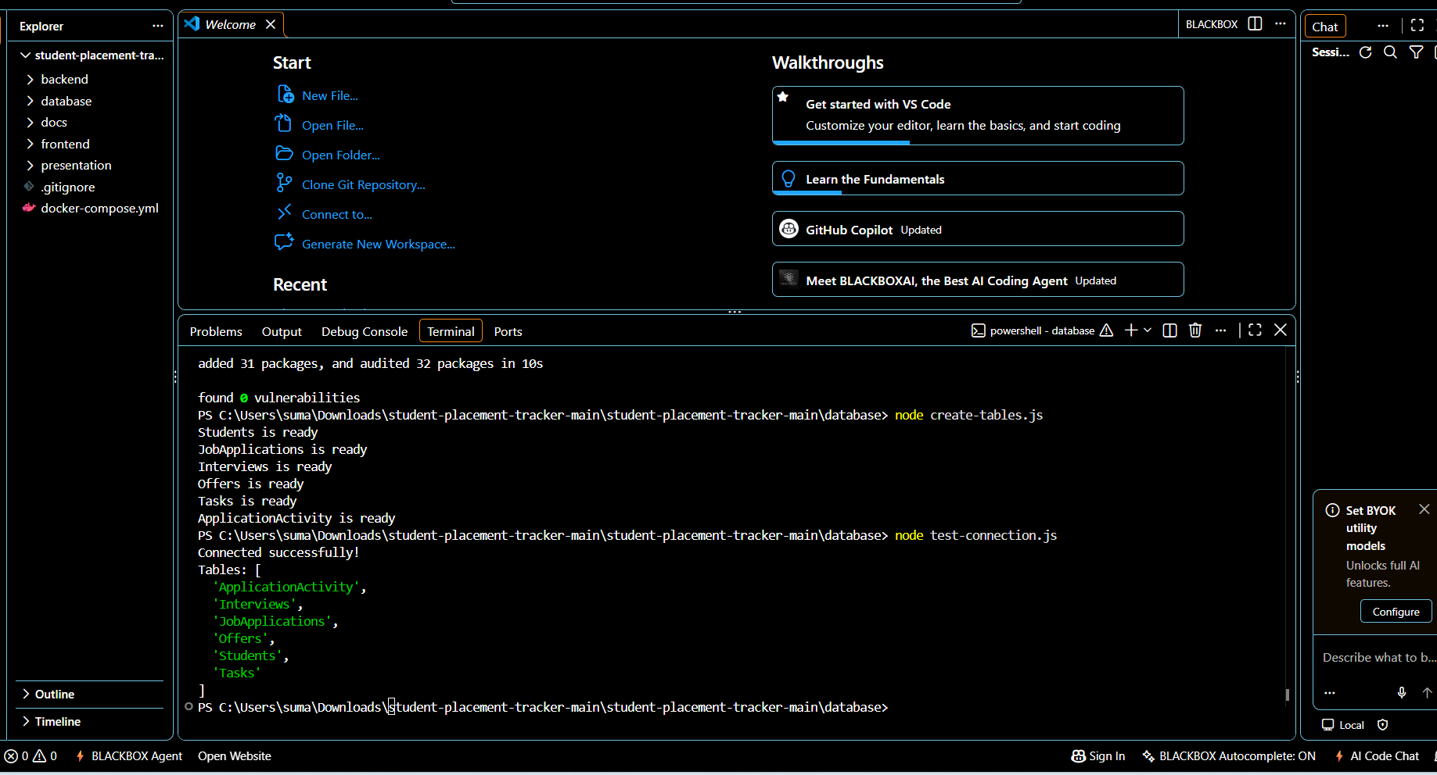

We ran create-tables.js and test-connection.js. The output showed that all six tables were ready and that the connection was working.
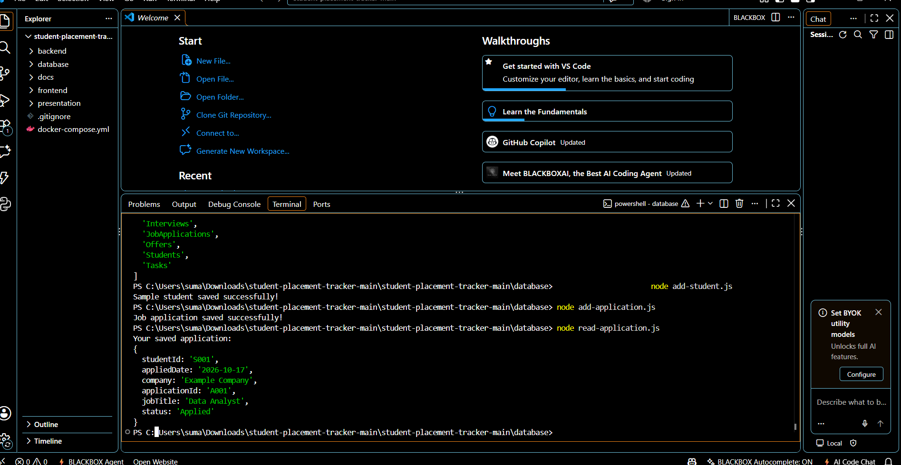

We also tested saving a student and an application using add-student.js and add-application.js. Then we ran read-application.js and got back application A001 for student S001 with its company, job title, and Applied status.
Workflow and Data Flow
How the application works
We first add a student and then record their job applications. We can update the application status and add interviews, offers, or tasks when needed. The steps below show how we use our project.
Student placement workflow
Step 1: Student
Add or select a student profile
↓
Step 2: Job application
Enter the company, job title, and date
↓
Step 3: Update status
Track the application as it progresses
↓
Step 4: Interview (if needed)
Add interview details on the Interviews page
↓
Step 5: Offer (if received)
Record the offer and its status
↓
Step 6: Task (if needed)
Add tasks and due dates
↓
Step 7: Dashboard
View the placement summary

Interviews, offers, and tasks are saved as separate records, but they are linked to the student or application. For example, changing an application status to Interview does not create an interview automatically. We add the interview details on the Interviews page.
How data moves in our project
When we add an application, React sends the form through frontend/src/api.js to POST /api/applications. Express passes the request to the controller and service. The service uses the AWS SDK to save the record in DynamoDB Local.
The result comes back through the backend as JSON, and React shows it on the page. We kept our database code in the service files, not in the frontend.
How the data moves
Step 1: React page
We enter the details in a form
↓
Step 2: frontend/src/api.js
Sends the HTTP request to the backend
↓
Step 3: Express route
Receives the request and selects the API
↓
Step 4: Controller
Checks the submitted details
↓
Step 5: Service + AWS SDK
Reads or writes the database record
↓
Step 6: DynamoDB Local
Stores the data or returns saved data
↓
Step 7: Backend response
Returns the result as JSON
↓
Step 8: React page
Shows the saved or updated information
Reading, updating, and deleting data
Read: When we open the Applications or Students page, the frontend uses GET /api/applications or GET /api/students to load the saved records.
Update: We use PUT /api/applications/:id to edit application details. The backend checks the status before saving it. If the application status changes, we also save a record in ApplicationActivity. The application update and activity record are two separate database writes.
Delete: DELETE /api/applications/:id checks whether an application has interviews, offers, or tasks linked to it. If so, deletion is blocked. Otherwise, the application and its activity history are deleted together in a transaction, within the history limit handled by our code.
What we tested
For testing, we created all six tables, checked the connection, and saved and read sample data. A student returned by /api/students also appeared on the website. We added a Test Company application, changed its status to Interview, and deleted it. These tests covered student reading and application CRUD, but not every interview, offer, or task operation.
Member Roles and Contributions
Pavani Seliveru – Frontend Development
- Designed the PlacementHub user interface using React.
- Developed Dashboard, Students, Applications, Interviews, Offers, and Tasks pages.
- Implemented forms, navigation, and interactive features.
Anusha Madari– Backend Development
- Developed REST APIs using Node.js and Express.
- Implemented CRUD operations.
- Connected the frontend with the backend.
Sumanjali Peketi– Database Management
- Configured Amazon DynamoDB Local.
- Created and managed six database tables.
- Implemented data storage, retrieval, and database testing.

